

2022

Year 11 Integrated Science – Unit 2

Task 6: Separating Solutions Investigation

|  |  |  |  |
| --- | --- | --- | --- |
| **Assessment Type:** |  | Name: |  |
| Investigation |  |
| **Duration & Conditions:**  60 minutes |  | Teacher: |  |
| Practical Experiment |  |  |  |
| **Assessment weighting:**  12.5 % of year mark |  | Date: |  |
| Weighting of this assessment in Task 6 Investigation: 6.25% | | | |

|  |  |
| --- | --- |
| **Total Mark** | $${}/{18}$$ |

Please see SEQTA for Teacher feedback and comments

## **INTRODUCTION:**

You are a forensic scientist at ChemCentre Perth and have been asked to analyse an ‘alcohol’ product that has been obtained from a local Perth bar. Your task is to determine if the ‘alcohol’ obtained is linked to a current watering down scandal that has scandal around Perth.

During the distillation process to create drinking alcohol, the different impure chemicals are distilled out at their various boiling points. Acetaldehyde (CH3CHO) is an aldehyde produced by plants as part of their normal metabolism. It is produced by the oxidation of ethanol. It has a boiling point of 20.8°C. Acetone ((CH3)2CO) is next with a boiling point of 56.2°C and is a colourless, flammable liquid. Methanol (CH3OH) is a colourless, volatile and highly flammable liquid with a boiling point of 64.7°C. Methanol poisoning is a highly toxic alcohol that is used industrially as a solvent, pesticide and alternative fuel source. Methanol poisoning occurs as a result of drinking beverages contaminated with methanol or from drinking methanol-contaminated products.

Ethanol (C2H5OH), also called ethyl alcohol, pure alcohol, grain alcohol or drinking alcohol is a volatile, flammable, colourless liquid. Due to its powerful effects on the human central nervous system and resulting changes in mood and behaviour, it is also one of the oldest recreational drugs. However, with the current economic struggles and the rise in price of living, some alcohol distributors have been watering-down their alcohol products before selling them onto their retailers.

The standard alcohol by volume (ABV) of most white spirits in Australia is 40%, however some of the spirits being sold in Perth bars have been as low as 4%.

Distillation is an extremely useful technique that is used to purify and separate liquid-liquid and liquid-solid mixtures. There are two types of distillation, simple and fractional distillation. Simple distillation is used to separate the components of a liquid-liquid mixture if the boiling points of the liquids are very different. If the boiling points of the liquids are close together, then fractional distillation *should* be used.

In this experiment we will be separating ethanol and water. The boiling points of these are 78°C and 100°C respectively. Because we have limited resources and are not in a high-tech forensics’ laboratory, we will use simple distillation to extract the ethanol determine the strength of the alcohol obtained during the seizure.

Due to the flammability and toxicity of ethanol, there are some safety instructions that MUST be followed.

1. Safety glasses and gloves MUST always be worn.
2. DO NOT inhale any of the fumes produced and keep lids/stoppers on all containers when not in use.
3. DO NOT EAT OR DRINK ANYTHING DURING THIS EXPERIMENT!
4. Wash hands thoroughly after completing the experiment and before eating anything.
5. No open flames, sparks, or hot surfaces.

## **EXPERIMENT:**

1. 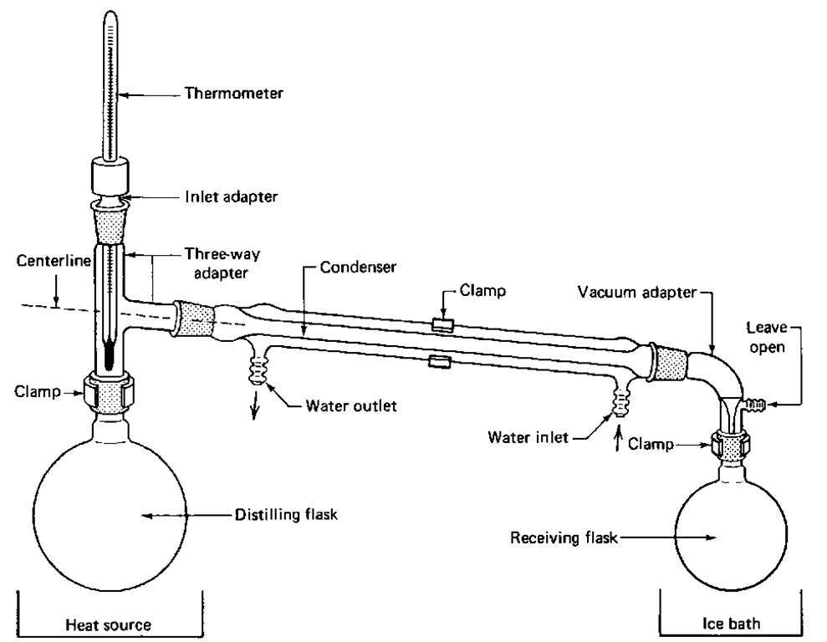Draw a labelled diagram of the distillation apparatus in the space below. (4 marks)

* 2 mark pencil, ruler, & 2D drawing
* 1 mark clearly labelled
* 2 marks includes all equipment

1. Observations of the seized alcohol mixture. (2 marks)

Colour? Odour? Weight? Volume?

* 1 mark descriptors of liquid
* 1 mark weight/volume of liquid

1. Identify the independent, dependent, and at least two controlled variables for this experiment (5 marks)

* Independent variable: temperature of the solution
* Dependent variable: the rate of distillation of ethanol
* Controlled variables: volume of solution being distilled, rate of temperature increase,

After you have set up the distillation apparatus similar to that on display, follow the next steps of the experimental procedure:

1. Start the stream of water through the condenser tube so that it flows form the bottom to the tap, out of the outlet and into the sink.
2. Add the alcohol mixture into the distilling flask and replace the rubber stopper and thermometer.
3. Heat the mixture carefully, slowly increasing the temperature of the hotplate (and water bath) until the mixture starts to vaporise.
4. Record the temperature at which the distillate liquid starts to condense and be collected into the graduated cylinder.
5. Record the temperature and volume of distillate collected at 30 second intervals.
6. Complete the following table of results (4 marks)

|  |  |  |
| --- | --- | --- |
| Time (minutes) | Temperature of mixture °C | Drops of distillate |
|  |  | 0 |
|  |  |  |
|  |  |  |

* 2 marks accurate temperature recording
* 2 marks accurate counting of drops per 30 seconds

1. Observations of the purified mixture. (2 marks)

Colour? Odour? Weight? Volume?

* 1 mark descriptors of liquid
* 1 mark weight/volume of liquid

1. Using the mass before and after distillation, was ABV of the alcohol analysed? Calculate this as a percentage and show your working. (1 mark)

* 1 mark for accurately calculating percentage of alcohol.
* Percentage should be approximately 5%, ±3%



2022

Year 11 Integrated Science – Unit 2

Task 6: Separating Solutions Investigation - VALIDATION

|  |  |  |  |
| --- | --- | --- | --- |
| **Assessment Type:** |  | Name: |  |
| Validation |  |
| **Duration & Conditions:**  60 minutes |  | Teacher: |  |
| Test conditions |  |  |  |
| **Assessment weighting:**  12.5 % of year mark |  | Date: |  |
| Weighting of this assessment in Task 6 Investigation: 6.25% | | | |

|  |  |
| --- | --- |
| **Total Mark** | $${}/{24}$$ |

Please see SEQTA for Teacher feedback and comments

I acknowledge that all the information contained in this task is my own work and not taken from other sources. If other sources have been used, they have been acknowledged in my references.

___________________________________

(Student Signature)

To prepare for the students doing the experiment, Mr McPherson and Mrs Agnew decided to do the experiment themselves. They used 100mL of the alcohol mixture and ended up with 16mL of ethanol at the end. The rate of distillate that they recorded over 10 minutes is detailed below.

|  |  |  |
| --- | --- | --- |
| Time (minutes) | Temperature of mixture °C | Drops of distillate |
| 0.00 | 63 | 0 |
| 0.30 | 65 | 0 |
| 1.00 | 67 | 0 |
| 1.30 | 69 | 0 |
| 2.00 | 70 | 0 |
| 2.30 | 72 | 1 |
| 3.00 | 73 | 1 |
| 3.30 | 75 | 2 |
| 4.30 | 76 | 2 |
| 5.00 | 78 | 3 |
| 5.30 | 78 | 5 |
| 6.00 | 78 | 7 |
| 6.30 | 79 | 10 |
| 7.00 | 79 | 14 |
| 8.30 | 79 | 16 |
| 9.00 | 79 | 16 |
| 9.30 | 80 | 16 |
| 10.00 | 80 | 15 |

## **EXPERIMENT ANALYSIS:**

Using the data from the distillation experiment you have conducted, complete the following questions.

1. What was the aim of this experiment? (1 mark)

* 1 mark: to determine if the alcohol obtained was at the legal ABV standard or less/more than.

1. List at least the safety requirements that were required to conduct this experiment and why they were necessary. (4 marks)

* 2 marks for listing safety requirements
* 2 marks for explaining why the requirements are necessary

1. Create an appropriate graph of the time and temperature using the data your have collected. (5 marks)

* 1 mark title
* 1 mark axis labels with units
* 1 mark equal scale
* 1 mark plotted correctly



1. What was the temperature at which the mixture first starts to boil? (1 mark)

* 1 mark for correctly identifying boiling point

1. Explain how the water bath was at 100°C (the water was boiling) but the ethanol/water mixture only reached approximately 80°C? (2 marks)

* 1 mark for explaining that ethanol boils at a lower temperature
* 1 mark for explaining that the ethanol in the mixture is lowering the boiling temperature

1. Why do you think we used a water bath for the distillation process? Was it necessary? (2 marks)

* 1 mark for saying that ethanol is highly flammable
* 1 mark for stating that the water bath allowed for the mixture to be heated without a flame

1. Describe the process of distillation and explain why we can utilise the separation technique to purify our alcohol and water mixture? (4 marks)

* 3 marks for describing how distillation works
* 1 mark for explaining that ethanol has a lower boiling point than water

1. Make a statement about the effectiveness of simple distillation to separate ethanol and water. Include references about boiling points, and your observations of starting and final mixtures. (2 marks)

* 1 mark for reference of boiling points
* 1 mark for observations on mixtures

1. After completing the analysis of the alcohol, write a statement for the detectives working this case about the strength of the alcohol that you analysed and if it is useful evidence for the investigation. (2 marks)

* 1 mark for strength of alcohol analysed
* 1 mark for stating if it is useful to the investigation